Contents

Word2Vec 1

Applications 1

Limitations 1

Word2Vec: Model Building and Examples 3

Word2Vec Model Parameters 3

Passive Aggressive Classifiers 5

Term Frequency Inverse Document Frequency (TFIDF) 6

Term Frequency 6

Inverse Document Frequency 6

Fake News Detection 6

Visualizing CNN Output with Trulens 8

Observing How an Image is Processed In Each Layer of the CNN 13

Using MaskVisualizer from TruLens to Observe Where Model Focused 14

Visualizing the Gradient of the Prediction Output Using IntegratedGradients from TruLens 15

Calculating Attributions for Individual Neurons 16

## Word2Vec

Word2vec is a natural language processing technique created in 2013 by a team of researchers at Google. As the name itself suggests, word2vec takes a text input and produces vectors that represent each word. For documentation see <https://www.tensorflow.org/tutorials/text/word2vec>

The algorithm uses a neural network model to learn word associations from the training dataset. The assumption of Word2Vec is that words share similar contexts. For instance: "dog", "puppy" and "pup" are often used in similar situations, with similar surrounding words like "good", "fluffy" or "cute". Word2Vec can be used for text classification or clustering.

### Applications

* Word Clustering
* Spell Checker
* Suggest additional words for a partial sentence

### Limitations

* Model results can be heavily based on the training dataset.
* The result of training can also be sensitive to parametrization.
* The algorithm may be outdated now and transformer models are more commonly used in natural language processing.

Example : Pre-Trained Model

The creators of Word2Vec have published pre-trained vectors trained on part of [Google News dataset](https://drive.google.com/file/d/0B7XkCwpI5KDYNlNUTTlSS21pQmM/edit?resourcekey=0-wjGZdNAUop6WykTtMip30g) (about 100 billion words). The model contains 300-dimensional vectors for 3 million words and phrases. Loading the model may take some time since the training set is large (about 1.6GB).

pip install genism

|  |
| --- |
| import gensim.downloader as api  # Load pre-trained vectors trained on part of Google News dataset (about 100 billion words).  # The model contains 300-dimensional vectors for 3 million words and phrases.  model = api.load('word2vec-google-news-300')  print("\nTop 10 words most similar to dog:")  print(model.most_similar("dog"))  print("\nSimilarity between day and night.")  print(model.similarity("day", "night"))  print ("\nThe imposter among [breakfast, lunch, dinner, chocolate] is:")  print(model.doesnt_match("breakfast lunch dinner chocolate".split())) |

The code outputs the following:

|  |
| --- |
| Top 10 words most similar to dog:  [('dogs', 0.8680489659309387), ('puppy', 0.8106428384780884), ('pit_bull', 0.780396044254303), ('pooch', 0.7627376914024353), ('cat', 0.7609457969665527), ('golden_retriever', 0.7500901818275452), ('German_shepherd', 0.7465174198150635), ('Rottweiler', 0.7437615394592285), ('beagle', 0.7418621778488159), ('pup', 0.740691065788269)]  Similarity between day and night.  0.50700074  The imposter among [breakfast, lunch, dinner, chocolate] is:  chocolate |

Exercise (2 marks)

Run the code but swap in an animal whose first letter starts with the same letter as your first name. Also swap in your first name instead of mine.

|  |
| --- |
| import gensim.downloader as api  # Load pre-trained vectors trained on Google News dataset (about 100 billion words).  # The model contains 300-dimensional vectors for 3 million words and phrases.  model = api.load('word2vec-google-news-300')  print("\nTop 10 words most similar to porcupine:")  print(model.most_similar("porcupine"))  print("\nSimilarity between porcupine and dogs.")  print(model.similarity("porcupine", "dongs"))  print ("\nThe imposter among [breakfast, lunch, dinner, pat] is:")  print(model.doesnt_match("breakfast lunch dinner pat".split())) |

Show a screenshot of the output:

|  |
| --- |
|  |

## Word2Vec: Model Building and Examples

It is possible to train a Word2Vec model on a custom domain. There are two types of Word2Vec models:

1. CBOW

CBOW is a predictive modeling technique used to predict a word given the context of the surrounding words. In this model, the algorithms use the context of the words to predict the target word. For example, if the context words are "the", "cat", and "is", the model will likely predict "sleeping".

1. Skip Gram

Skip-Gram is the opposite of CBOW. This model predicts the context words given the target word. For example, if the target word is "sleeping", the model will predict the context words "the", "cat", and "is".

### Word2Vec Model Parameters

Here are some key parameters for the word2vec model. The complete list can be found at [gensim](https://radimrehurek.com/gensim/models/word2vec.html).

* **sentences** *(iterable of iterables, optional)* – The sentences iterable can be a list of lists of tokens, or an iterable that streams the sentences directly from disk/network.
* **corpus_file** *(str, optional)* – Path to a corpus file in LineSentence format. You may use this argument instead of sentences to get performance boost. Only one of sentences or corpus_file arguments need to be passed
* **vector_size** *(int, optional)* – Dimensionality of the word vectors.
* **window** *(int, optional)* – Maximum distance between the current and predicted word within a sentence.
* **min_count** *(int, optional)* – Ignores all words with total frequency lower than this.
* **workers** *(int, optional)* – Use these many worker threads to train the model (=faster training with multicore machines).
* **sg** *({0, 1}, optional)* – Training algorithm: 1 for skip-gram; otherwise CBOW.
* **epochs** *(int, optional)* – Number of iterations (epochs) over the corpus. (Formerly: iter)

Example : Training Word2Vec Model

This example shows how to train a Word2Vec model on custom text. The text is limited so the model is not very good.

The program uses both CBOW and SKIP Gram models to find similarity scores between tail and fox. It also identifies words closest to fox. Spoiler alert: In case you did not know this, the fox offers to take the gingerbread man across the river on his back but it’s a trick and the fox eats him. The context words found by the model help to reveal this unfortunate turn of events.

|  |
| --- |
| SKIP CBOW Model  Similarity score between 'tail' and 'fox' - CBOW: -0.025201058  Most similar words to fox and tail - CBOW: [('decided', 0.2885017991065979), ('snapped', 0.25704067945480347), ('in', 0.2104814499616623), ('back.', 0.20662857592105865), ('re', 0.19860148429870605), ('out', 0.1933133453130722), ('take', 0.192650705575943), ('nose', 0.18367135524749756), ('when', 0.17450621724128723), ('yard', 0.16885673999786377)]  SKIP GRAM Model  Similarity score between 'tail' and 'fox' - Skip Gram: 0.7708877  Most similar to 'tail' and 'fox' - Skip Gram: [('decided', 0.1650265008211136), ('yard', 0.130541130900383), ('nose', 0.11839824169874191), ('when', 0.10730229318141937), ('halfway', 0.10551087558269501), ('back.', 0.10312772542238235), ('shape', 0.10216770321130753), ('snapped', 0.08792714029550552), ('upon', 0.08604012429714203), ('don', 0.08323509991168976)] |

Here is the code:

|  |
| --- |
| # import nltk for tokenizing sentences and words  import nltk  nltk.download('punkt')  from nltk.tokenize import sent_tokenize, word_tokenize  # import word2vec model  import gensim  from gensim.models import Word2Vec  # Reads ‘alice.txt’ file  data_file = open("./gingerbread_man.txt", encoding="utf8")  text = data_file.read()  # Replaces escape character with space  cleaned_text = text.replace("\n", " ")  data = []  # iterate through each sentence in the file  for sentence in sent_tokenize(cleaned_text):  words = []  # tokenize the sentence into words  for word in word_tokenize(sentence):  words.append(word.lower())  data.append(words)  # Create CBOW model  cbow_model = gensim.models.Word2Vec(data, min_count=1, vector_size=100,  window=5, batch_words=1000)  # Print results  print("\nSKIP CBOW Model")  print("Similarity score between 'tail' " +  "and 'fox' - CBOW : ",  cbow_model.wv.similarity('tail', 'fox'))  # Print results  print("Most similar words to fox and tail - CBOW : ",  cbow_model.wv.most_similar('tail', 'fox'))  # Create Skip Gram model  print("\nSKIP GRAM Model")  skip_gram_model = gensim.models.Word2Vec(data, min_count=1,  vector_size=100, window=5,  batch_words = 1000, sg=1)  # Print results  print("Similarity score between 'tail' " +  "and 'fox' - Skip Gram : ",  skip_gram_model.wv.similarity('tail', 'fox'))  # Print results  print("Most similar to 'tail' and 'fox' - Skip Gram : ",  skip_gram_model.wv.most_similar('tail', 'fox')) |

## Passive Aggressive Classifiers

The passive aggressive classifier algorithm is an online learning algorithm, which means that it can update its weights as new data comes in. The passive aggressive classifier has a parameter, namely, the regularization parameter, C that allows for a trade-off between the size of the margin and the number of misclassifications. In each iteration, the passive aggressive classifier looks at a new instance, assesses whether it has been correctly classified or not, and then updates its weights accordingly. If the instance is correctly classified, there is no change in weight. However, if it is misclassified, the passive aggressive algorithm adjusts its weights in order to better classify future instances based on this misclassified instance. The degree to which the Passive Aggressive algorithm adjusts its weights is dependent on the regularization parameter C and how confident it is in the classification of that particular instance.

As with other supervised learning algorithms, the passive aggressive classifier works by taking a set of training data and dividing it into two groups: a training set and a test set. The passive aggressive classifier then uses the training set to learn how to correctly classify objects into one of two categories.

In each iteration, the passive aggressive classifier looks at a new instance, assesses whether it has been correctly classified or not, and then updates its weights accordingly. If the instance is correctly classified, there is no change in weight. However, if it is misclassified, the passive aggressive algorithm adjusts its weights in order to better classify future instances based on this misclassified instance. The degree to which the Passive Aggressive algorithm adjusts its weights is dependent on the regularization parameter C and how confident it is in the classification of that particular instance.

<https://vitalflux.com/passive-aggressive-classifier-concepts-examples/>

## Term Frequency Inverse Document Frequency (TFIDF)

TFIDF vectors can be used with passive aggressive classifiers for grouping text.

TFIDF works by proportionally increasing the number of times a word appears in the document but is counterbalanced by the number of documents in which it is present. Hence, words like ‘this’, ’are’ etc., that are commonly present in all the documents are not given a very high rank. However, a word that is present too many times in a few of the documents will be given a higher rank as it might be indicative of the context of the document.

### Term Frequency

Term frequency is defined as the number of times a word (i) appears in a document (j) divided by the total number of words in the document.

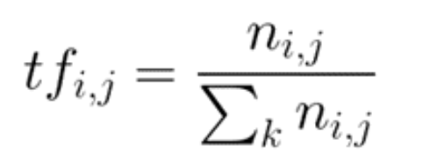

### Inverse Document Frequency

Inverse document frequency refers to the log of the total number of documents divided by the number of documents that contain the word. The logarithm is added to dampen the importance of a very high value of IDF.

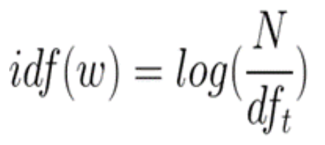

TFIDF is computed by multiplying the term frequency with the inverse document frequency.

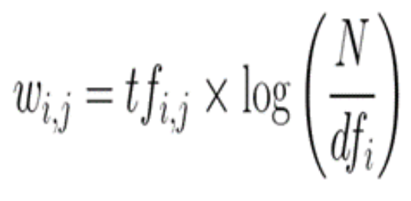

Reference:

<https://www.analyticsvidhya.com/blog/2021/07/bag-of-words-vs-tfidf-vectorization-a-hands-on-tutorial/#:~:text=TFIDF%20works%20by%20proportionally%20increasing,given%20a%20very%20high%20rank>.

### Fake News Detection

Passive aggressive classifiers trained with TFIDF vectors are useful for building models that detect fake news.

The steps for fitting the model are:

# 1. Initialize a TfidfVectorizer to remove stop words. 'a', 'is', 'the'

tfidf_vectorizer = TfidfVectorizer(stop_words='english', max_df=0.7)

# 2. Transform text to numeric TFIDF vectors.

tfidf_train = tfidf_vectorizer.fit_transform(x_train)

tfidf_test = tfidf_vectorizer.transform(x_test)

# 3. Initialize a PassiveAggressiveClassifier with TFIDF vectors.

pac = PassiveAggressiveClassifier()

pac.fit(tfidf_train,y_train)

Example : Fake News Detection

Here is the full code solution which builds the passive aggressive classifier for detecting fake news.

|  |
| --- |
| import numpy as np  import pandas as pd  import itertools  from sklearn.model_selection import train_test_split  from sklearn.feature_extraction.text import TfidfVectorizer  from sklearn.linear_model import PassiveAggressiveClassifier  from sklearn.metrics import accuracy_score, confusion_matrix, classification_report  #Read the data  df = pd.read_csv('/Users/pm/Downloads/FakeNews.csv')  #Get shape and head  print(df.shape)  print(df.head())  pd.set_option('display.max_colwidth', None)  print(df.head(1))  # Fake Articles  print("Number of FAKE articles: " + str(np.sum(df['label'] == 'FAKE')))  # Real Articles  print("Number of REAL articles: " + str(np.sum(df['label'] == 'REAL')))  # Fake Articles  print("Number of FAKE articles: " + str(np.sum(df['label'] == 'FAKE')))  # Real Articles  print("Number of REAL articles: " + str(np.sum(df['label'] == 'REAL')))  # Split the dataset  x_train, x_test, y_train, y_test = train_test_split(df['text'], df['label'], test_size=0.2, random_state=7)  # Initialize a TfidfVectorizer  tfidf_vectorizer = TfidfVectorizer(stop_words='english', max_df=0.7)  # Fit and transform train set, transform test set  tfidf_train = tfidf_vectorizer.fit_transform(x_train)  tfidf_test = tfidf_vectorizer.transform(x_test)  # Initialize a PassiveAggressiveClassifier  pac = PassiveAggressiveClassifier()  pac.fit(tfidf_train,y_train)  #- Predict on the test set and calculate accuracy  y_pred=pac.predict(tfidf_test)  score=accuracy_score(y_test,y_pred)  print(f'Accuracy: {round(score*100,2)}%')  # Build confusion matrix  confusion_matrix(y_test,y_pred, labels=['FAKE','REAL'])  # Creating classification report  print(classification_report(y_test, y_pred)) |

Exercise (3 marks)

Create two news items with your name in it.

data = np.array(['Pat McGee is going to space.', 'Pat McGee works at BCIT.'])

series = pd.Series(data)

Transform the data and make a prediction with the model to determine if the statements are true. Show the extra code needed to transform sentences with your name in it and to make predictions as to whether the statements are fake or not.

|  |
| --- |
| data = np.array(['Victor is going to space.', 'Victor studies at BCIT.'])  series = pd.Series(data)  # Transform the data  tfidf_data = tfidf_vectorizer.transform(series)  # Make a prediction  y_pred_data = pac.predict(tfidf_data)  # Print the predictions  for i in range(len(series)):      if y_pred_data[i] == 'FAKE':          print(f"The statement '{series[i]}' is FAKE.")      else:          print(f"The statement '{series[i]}' is TRUE.") |

Show a screenshot of your output here:

|  |
| --- |
|  |

## Visualizing CNN Output with Trulens

Convolutional Neural Networks (ConvNets or CNNs) have gained massive popularity in recent years, mostly being used to analyze visual imagery. Their applications are wide-ranging, from simple binary classifiers to complex models that are used in hospitals to identify tumors. Despite being so widely used, CNNs are still somewhat of a black box: it is not always clear “why” a model makes the prediction that it does. Without this information, how can researchers and developers be sure their models will work in the real world?

Trulens offers ways to analyze how a CNN image classifier model makes predictions. These analytical tools can help generate attention heatmaps for input images, showing us just where the model is looking when it makes a prediction. TruLens also provides additional insights such as showing the most important feature map in each layer, giving us important information for evaluating our models.

Trulens is compatible with Keras and Pytorch CNN’s. Documentation is available at:

<https://github.com/truera/trulens>

Example : Preparing the CNN for use with Trulens

The different steps in this section explain how to set up the CNN and how to prepare it for a visualization of its outputs.

To setup your system to run a project utilizing these tools, run the following import code in a Jupyter Notebook or Google Colab cell. I used Google Colab.

|  |
| --- |
| # Here are all the imports that we'll need. Please comment out if you have them installed (not neccessary just for peace of mind).  import sys  !{sys.executable} -m pip install trulens  !{sys.executable} -m pip install torchvision  !{sys.executable} -m pip install matplotlib  !{sys.executable} -m pip install pandas  !{sys.executable} -m pip install scipy  !{sys.executable} -m pip install tensorflow  !{sys.executable} -m pip install torchsummary  !{sys.executable} -m pip install torch  !{sys.executable} -m pip install IPython  !{sys.executable} -m pip install numpy --upgrade  !{sys.executable} -m pip install Pillow |

Next run the following import statement to import all of the relevant libraries into your Jupyter Notebook

|  |
| --- |
| # Import all the libraries we'll need  import json  import PIL  import requests  import scipy.misc  import torch  import torch.nn as nn  import torchvision  import matplotlib.pyplot as plt  import matplotlib.cm as cm  import numpy as np  import pandas as pd  import tensorflow as tf  import torchvision.utils as utils  import torchvision.models as models  import torchvision.transforms as transforms  from IPython.display import Image, display  from tensorflow import keras  from torchsummary import summary  from torch.autograd import Variable  from trulens.nn.attribution import InputAttribution  from trulens.nn.attribution import IntegratedGradients  from trulens.visualizations import ChannelMaskVisualizer  from trulens.visualizations import MaskVisualizer  from trulens.visualizations import HeatmapVisualizer  from trulens.nn.models import get_model_wrapper  from trulens.nn.attribution import InternalInfluence  from trulens.nn.distributions import PointDoi  from trulens.nn.quantities import ClassQoI, InternalChannelQoI, MaxClassQoI  from trulens.nn.slices import Cut, InputCut, OutputCut, Slice |

This next step will display the figures inline in your notebook cell.

|  |
| --- |
| # Display matplotlib figures in the cell  %matplotlib inline |

#### Load Pre-Trained PyTorch CNN Model

Now that the environment is setup, we’ll be importing a pre-trained VGG16 model from pyTorch. Just as a quick introduction, VGG16 is a CNN developed by the Visual Geometry Group from Oxford University. This model won the ImageNet Large Scale Visual Recognition Challenge (ILSVRC) in 2014, and is widely considered one of the best image classifier models to currently exist. It is able to classify over 1000 objects with ~93% accuracy. The 16 in VGG16 stands for 16 weighted layers (13 Convolution layers and 3 Dense layers).

This next block of code imports the pre-trained model and creates a wrapped model with TruLens, which we will use later for analysis. It will also print out a quick summary of the model, showing layers and output shapes.

|  |
| --- |
| # Create a Pytorch VGG16 model  pytorch_model = models.vgg16(pretrained=True)  device = 'cpu'    # Produce a wrapped model from the pytorch model for Trulens.  wrapped_model = get_model_wrapper(pytorch_model, input_shape=(3,224,224), device=device)  print(summary(pytorch_model, (3, 224, 224))) |

#### Transform Image to Appropriate Size

In the following block of code, we’ll use the Pillow library to open an image from a URL on your device and then make transformations on that image to an appropriate size in order to pass it to the VGG16 model. In Jupyter, it will also show a Matplotlib diagram of the original image.

You will need to upload an image to a place where your notebook can access it. Name your image accordingly.

|  |
| --- |
| url = "beaglebike.jpg"  with PIL.Image.open(url) as img:  x = np.array(img.resize((224,224), PIL.Image.ANTIALIAS))[np.newaxis]    # Pre-process uploaded image  normalize = transforms.Compose([  transforms.ToTensor(), # convert to [0, 1]    # Means and stddevs of ImageNet (calculated from their image library)  transforms.Normalize(  mean=[0.485, 0.456, 0.406],  std=[0.229, 0.224, 0.225])])  processed_image = np.array(normalize(x[0])).transpose(1, 2, 0)[np.newaxis]    # Transpose to [*, C, H, W] for PyTorch convention.  x = x.transpose(0, 3, 1, 2)  processed_image = processed_image.transpose(0, 3, 1, 2)  plt.imshow(img) |

Now that the model and input image are ready, we can make predictions. Before we pass the image through the model, we use the following code to collect some useful information along the way. This code will collect all the convolution layers.

#### Show Information about the CNN

Total convolution layers: 13

|  |
| --- |
| # we will save the conv layer weights in this list  model_weights =[]    #we will save the 13 conv layers in this list  conv_layers = []    # get all the model children as list  model_children1 = list(pytorch_model.children())  model_children = model_children1[0]    #counter to keep count of the conv layers  counter = 0    #append all the conv layers and their weights to the list  for i in range(len(model_children)):  if type(model_children[i]) == nn.Conv2d:  counter+=1  model_weights.append(model_children[i].weight)  conv_layers.append(model_children[i])  elif type(model_children[i]) == nn.Sequential:  for j in range(len(model_children[i])):  for child in model_children[i][j].children():  if type(child) == nn.Conv2d:  counter+=1  model_weights.append(child.weight)  conv_layers.append(child)  print(f"Total convolution layers: {counter}") |

#### Generator Proper Tensor Format

Then run the model, make transformations on the input image. This will print out the image shape before being passed to our model.

|  |
| --- |
| # run the model with cuda if available, else use cpu  device = torch.device("cuda" if torch.cuda.is_available() else "cpu")  x_model = pytorch_model.to(device)    # show how transformations change image shape  transform = transforms.Compose([  transforms.Resize((224, 224)),  transforms.ToTensor(),  transforms.Normalize(mean=[0.485, 0.456, 0.406],  std=[0.229, 0.224, 0.225])])  image = transform(img)  print(f"Image shape before: {image.shape}")  image = image.unsqueeze(0)  print(f"Image shape after: {image.shape}")  image = image.to(device) |

#### Show the Convolutional Layers

Now, just for a quick double-check, print out the names of all of the convolution layers:

Name: Conv2d(3, 64, kernel_size=(3, 3), stride=(1, 1), padding=(1, 1)); Shape:torch.Size([1, 64, 224, 224])

Name: Conv2d(64, 64, kernel_size=(3, 3), stride=(1, 1), padding=(1, 1)); Shape:torch.Size([1, 64, 224, 224])

Name: Conv2d(64, 128, kernel_size=(3, 3), stride=(1, 1), padding=(1, 1)); Shape:torch.Size([1, 128, 224, 224])

Name: Conv2d(128, 128, kernel_size=(3, 3), stride=(1, 1), padding=(1, 1)); Shape:torch.Size([1, 128, 224, 224])

Name: Conv2d(128, 256, kernel_size=(3, 3), stride=(1, 1), padding=(1, 1)); Shape:torch.Size([1, 256, 224, 224])

Name: Conv2d(256, 256, kernel_size=(3, 3), stride=(1, 1), padding=(1, 1)); Shape:torch.Size([1, 256, 224, 224])

Name: Conv2d(256, 256, kernel_size=(3, 3), stride=(1, 1), padding=(1, 1)); Shape:torch.Size([1, 256, 224, 224])

Name: Conv2d(256, 512, kernel_size=(3, 3), stride=(1, 1), padding=(1, 1)); Shape:torch.Size([1, 512, 224, 224])

Name: Conv2d(512, 512, kernel_size=(3, 3), stride=(1, 1), padding=(1, 1)); Shape:torch.Size([1, 512, 224, 224])

Name: Conv2d(512, 512, kernel_size=(3, 3), stride=(1, 1), padding=(1, 1)); Shape:torch.Size([1, 512, 224, 224])

Name: Conv2d(512, 512, kernel_size=(3, 3), stride=(1, 1), padding=(1, 1)); Shape:torch.Size([1, 512, 224, 224])

Name: Conv2d(512, 512, kernel_size=(3, 3), stride=(1, 1), padding=(1, 1)); Shape:torch.Size([1, 512, 224, 224])

Name: Conv2d(512, 512, kernel_size=(3, 3), stride=(1, 1), padding=(1, 1)); Shape:torch.Size([1, 512, 224, 224])

Here is the code:

|  |
| --- |
| outputs = []  names = []  for layer in conv_layers[0:]:  image = layer(image)  outputs.append(image)  names.append(str(layer))    joined = list(zip(names,outputs))  for i in joined:  print(f"Name: {i[0]}; Shape:{i[1].shape}") |

### Observing How an Image is Processed In Each Layer of the CNN

Example : Observing how an Image is Processed in Each Layer of the CNN

The code below will use the data we set up earlier to show how the image is processed by VGG16 at each convolution layer. You can see how edges are being collected, and how the Gaussian blur is applied. You can see how it gets less and less detail as it goes further.

|  |
| --- |
| processed = []  for feature_map in outputs:  feature_map = feature_map.squeeze(0)  gray_scale = torch.sum(feature_map,0)  gray_scale = gray_scale / feature_map.shape[0]  processed.append(gray_scale.data.cpu().numpy())    fig = plt.figure(figsize=(30, 50))  for i in range(len(processed)):  a = fig.add_subplot(5, 4, i+1)  imgplot = plt.imshow(processed[i])  a.axis("off")  a.set_title(names[i].split('(')[0], fontsize=30)  plt.savefig(str('feature_maps.jpg'), bbox_inches='tight') |

Figure : Output from Each Convolutional Layer



Exercise (1 mark)

Do not overthink this question. I am just aiming for a basic understanding. Please explain why there are 13 images in Figure 1.

|  |
| --- |
| There are 13 convolution layers |

Exercise (1 mark)

What can you say about the amount of detail in each image that is output from one convolutional layer to the next?

|  |
| --- |
| After each layer, the extracted feature become more complex. |

#### Showing the Predictions

Example : Showing the Predictions

Now, use the model to print out prediction scores for all of the labels in the Imagenet classification library. To run this code you will need to download the *.json file and upload it to Google Colab.

<https://github.com/raghakot/keras-vis/blob/master/resources/imagenet_class_index.json>

|  |
| --- |
| # Make predictions using pytorch model and write them to output  with torch.no_grad():  output = pytorch_model(torch.from_numpy(processed_image).to('cpu')).cpu().numpy()  df = pd.DataFrame(output)  df = df.transpose()  df  # Open classifications file  with open('imagenet_class_index.json') as file:  classes_index = json.load(file)    # change indexes to labels  labels_from_index = [classes_index[str(x)][1] for x in range(len(classes_index))]  top_labels = [  (j, labels_from_index[j], output[0][j])  for j in np.argsort(output[0])[::-1][:10]]    # Top 10 predictions of image by pytorch VGG16  df = pd.DataFrame(top_labels, columns=["Index", "Name", "Score"])  df |

The output shows a listing of objects that have been detected.

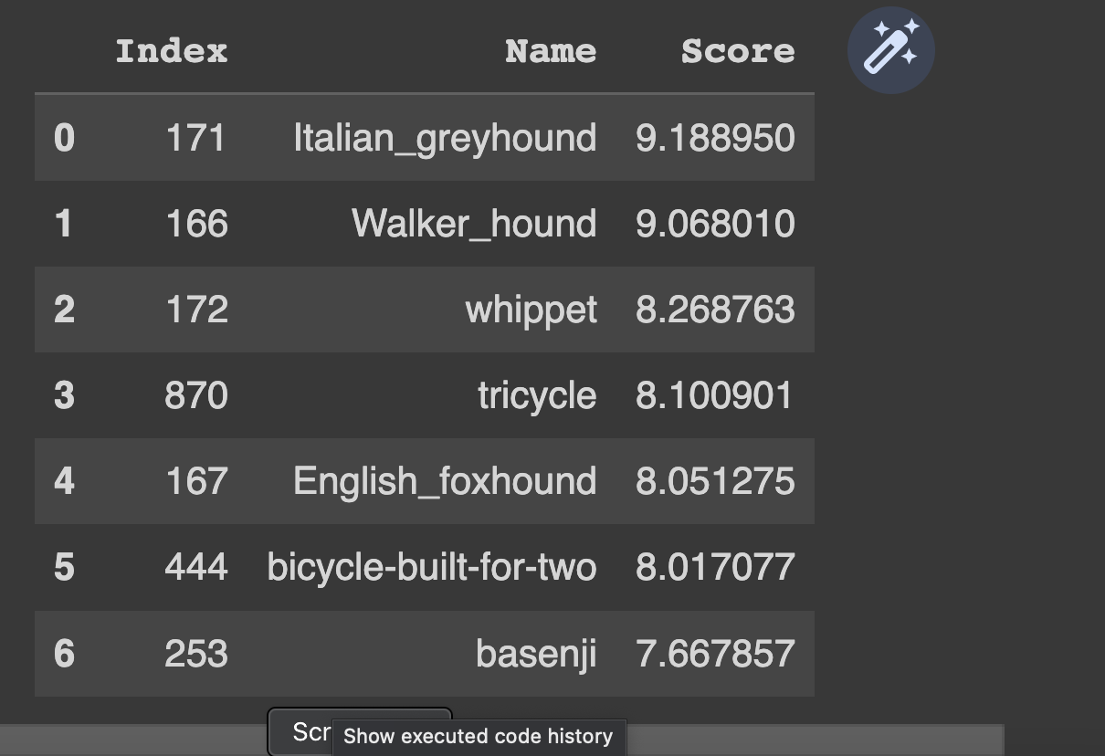

### Using MaskVisualizer from TruLens to Observe Where Model Focused

A MaskVisualizer can be used to highlights pixels where the model focused most when making the predictions. This visualizer receives blur and threshold parameters. **Blur** helps users see a more generalized area of interest. **Threshold** selects the areas of most interest.

Figure : Observing Areas of Model Focus Using MaskVisualizer

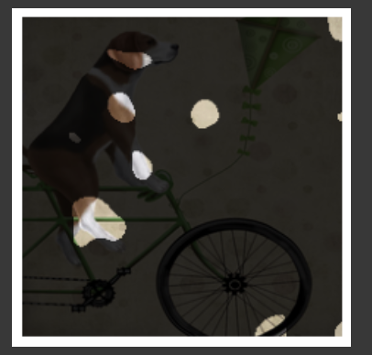

Example : Observing with the CNN Model Focused

This code generates a saliency map to highlight the features that were observed the most by the model for classification.

|  |
| --- |
| from trulens.nn.attribution import InputAttribution  from trulens.nn.attribution import IntegratedGradients  from trulens.visualizations import MaskVisualizer    # A mask is applied to reveal the top threshold % of pixels by attribution.  infl = InputAttribution(wrapped_model)  attrs_input = infl.attributions(processed_image)  masked_image = MaskVisualizer(blur=10, threshold=0.95)(attrs_input, x) |

Exercise (2 marks)

Run the code above again but use blur = 7 and threshold=0.90. Show the output result.

|  |
| --- |
| Original picture: |

Explain how the output is different than the output in Figure 2.

|  |
| --- |
| Using a blur of 7 results in less blur than a blur of 10. There are more details in the result but also more noise. Using a threshold of 0.90 results in a mask highlighting 90% of the pixels through attribution. Similarly using a threshold of 0.95 results in a mask highlighting 95% of the pixels. |

### Visualizing the Gradient of the Prediction Output Using IntegratedGradients from TruLens

IntegratedGradients from TruLens, computes the gradient of the model’s prediction output. The integrated gradients (IG) method is widely used to evaluate the extent to which each feature contributes to the classification.

Figure : Observing Gradient Output with a Saliency Map and a Heatmap

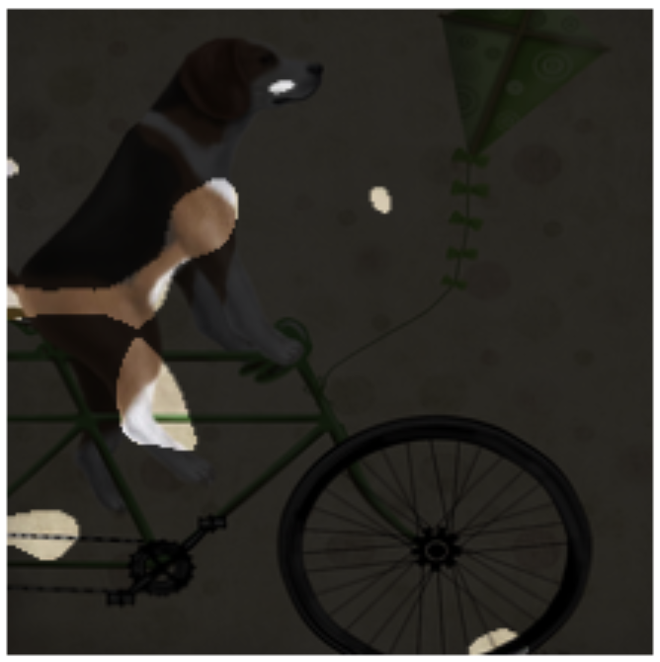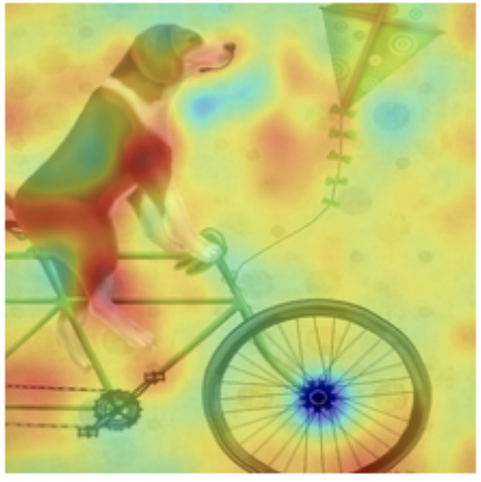

Example : Observing Gradient Output with a Saliency Map and a Heatmap

|  |
| --- |
| infl = IntegratedGradients(wrapped_model, resolution=10)  attrs_input = infl.attributions(processed_image)  masked_image = MaskVisualizer(blur=10, threshold=0.95)(attrs_input, x)  infl = IntegratedGradients(wrapped_model, resolution=10)  attrs_input = infl.attributions(processed_image)  masked_image = HeatmapVisualizer(blur=10)(attrs_input, x) |

Exercise (1 mark)

Explain why the gradient of the prediction is important.

|  |
| --- |
| Calculating the gradient helps identify important input features. With this information we can improve the models performance. |

### Calculating Attributions for Individual Neurons

An attribution measures the contribution of a function’s output in the classification model. The code below shows TruLens’ how to calculate attributions for individual neurons within a model. TruLens can reveal how feature maps in each layer are critical for model decision-making.

Example : Calculating and Showing Attributions for Individual Neurons

|  |
| --- |
| from trulens.nn.attribution import InternalInfluence  from trulens.nn.distributions import PointDoi  from trulens.nn.quantities import ClassQoI, InternalChannelQoI, MaxClassQoI  from trulens.nn.slices import Cut, InputCut, OutputCut, Slice  # Slice defines a layer to use for internal attributions.  # QoI (quantity of interest), defines the model behavior to explain using  # attributions, it is the output of some layer.  # DoI (distribution of interest) specifies points surrounding each record for  # attribution calculations.    # Define the influence measure.  infl = InternalInfluence(  wrapped_model,  Slice(Cut('features_28'), OutputCut()),  MaxClassQoI(),  PointDoi())    attrs_internal = infl.attributions(processed_image).sum(axis=(2,3)) |

This following code will show the top feature map in features_28, model at that layer.

Number of neurons in layer features_28: 512

Top feature map: 3

|  |
| --- |
| # Define the influence measure.  infl = InternalInfluence(wrapped_model, 'features_28', 'max', 'point')    # Get the attributions for the internal neurons at layer 'features_28'. Because  # layer 'features_28' contains 2D feature maps, we take the sum over the width  # and height of the feature maps to obtain a single attribution for each feature  # map.  attrs_internal = infl.attributions(processed_image).sum(axis=(2,3))  print(f"Number of neurons in layer features_28: {len(attrs_internal[0])}")    top_feature_map = int(attrs_internal[0].argmax())    print('Top feature map:', top_feature_map) |

And this code will show the image with an attention mask for that layer:

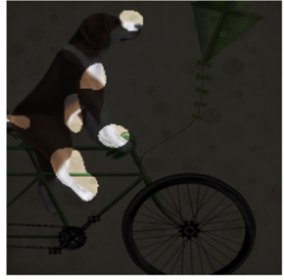

|  |
| --- |
| # Since feature maps represent learned features we can’t easily interepret them  # But Trulens can use a second set of attributions to find input features that are  # most important in defining THIS particular feature map  masked_image = ChannelMaskVisualizer(  wrapped_model,  'features_28',  top_feature_map,  blur=10,  threshold=0.95)(x, processed_image)  plt.axis('off')  plt.imshow(masked_image[0].transpose((1,2,0))) |

Exercise (2 marks)

How many feature maps are there? Explain how you figured this number out?

|  |
| --- |
| There are 512 feature maps in the “features_28” layer.  Length of the first element attrs_internal = infl.attributions(processed_image).sum(axis=(2,3)) |

Exercise (1 mark)

Show the visualization for features_27.

|  |
| --- |
|  |